1) Yelp dataset 다운로드(6 json files)

<https://www.yelp.com/dataset>

**yelp_dataset.tar.gz**

2) AWS 계정 생성(기생성) 및 Acces Key 생성

AWS 로그인 -> 오른쪽상단 계정명 -> 내 보안 자격증명( [My Security Credentials](https://console.aws.amazon.com/iam/home?region=ap-northeast-2#security_credential)) ->

액세스 키(액세스 키 ID 및 보안 액세스 키)

Access keys (access key ID and secret access key) -> 새 액세스키 만들기 -> rootkey.csv파일 다운

3) AWS Configure

- AWS CLI download

- AWS CLI

|  |
| --- |
| $ aws configure  AWS Access Key ID [None] : *Access key ID 입력*  AWS Secret Access Key [None] : Secret *Access key 입력*  Default region name [None] :  Default output format [None] : |

4) S3 bucket, 폴더 생성

- Amazon S3 -> Create bucket -> sk002yelp 버킷 생성

- Json 파일명에 맞는 폴더 생성

5) File Upload

- Json 파일 업로드

|  |
| --- |
| $ aws s3 ls  $ aws s3 cp photos.json s3://sk002yelp/photos  …  $ aws s3 cp review.json s3://sk002yelp/review |

6) Key-pairing

- AWS EC3 dashboard -> Network & Security -> Key Pairs

- Create Key Pair -> 키명 입력후 키 생성 및 다운로드

- ~/.ssh/폴더에 저장

- Ssh keygen

- 서비스 -> EC2 -> 네트워크 및 보안 -> 보안그룹 -> 작업(인바운드규칙편집) -> 규칙추가 -> ssh

7) EMR Cluster 생성

- Amazon EMR -> Create Cluster

- S/W : Hadoop, jupyterhub, hive, hue, spark, zeppelin, tez, sqoop, hcatalog, pig

- h/w ; master 1 instance, core 4 instances, task 0 instance

8) SSH connection 확인

- ssh -i ~/*mykey*.pem hadoop@ec2-13-125-115-186.ap-northeast-2.compute.amazonaws.com

9) Web UI 활성화

- SSH 터널 설정

ssh -i *mykey*.pem -ND 8157 hadoop@ec2-13-125-115-186.ap-northeast-2.compute.amazonaws.com

- Proxy 설정

Google chrome extension으로 foxtyproxy 설치

Foxyproxy-settings.xml 저장

|  |
| --- |
| <?xml version="1.0" encoding="UTF-8"?>  <foxyproxy>  <proxies>  <proxy name="emr-socks-proxy" id="2322596116" notes="" fromSubscription="false" enabled="true" mode="manual" selectedTabIndex="2" lastresort="false" animatedIcons="true" includeInCycle="true" color="#0055E5" proxyDNS="true" noInternalIPs="false" autoconfMode="pac" clearCacheBeforeUse="false" disableCache="false" clearCookiesBeforeUse="false" rejectCookies="false">  <matches>  <match enabled="true" name="*ec2*.amazonaws.com*" pattern="*ec2*.amazonaws.com*" isRegEx="false" isBlackList="false" isMultiLine="false" caseSensitive="false" fromSubscription="false" />  <match enabled="true" name="*ec2*.compute*" pattern="*ec2*.compute*" isRegEx="false" isBlackList="false" isMultiLine="false" caseSensitive="false" fromSubscription="false" />  <match enabled="true" name="10.*" pattern="http://10.*" isRegEx="false" isBlackList="false" isMultiLine="false" caseSensitive="false" fromSubscription="false" />  <match enabled="true" name="*10*.amazonaws.com*" pattern="*10*.amazonaws.com*" isRegEx="false" isBlackList="false" isMultiLine="false" caseSensitive="false" fromSubscription="false" />  <match enabled="true" name="*10*.compute*" pattern="*10*.compute*" isRegEx="false" isBlackList="false" isMultiLine="false" caseSensitive="false" fromSubscription="false" />  <match enabled="true" name="*.compute.internal*" pattern="*.compute.internal*" isRegEx="false" isBlackList="false" isMultiLine="false" caseSensitive="false" fromSubscription="false"/>  <match enabled="true" name="*.ec2.internal* " pattern="*.ec2.internal*" isRegEx="false" isBlackList="false" isMultiLine="false" caseSensitive="false" fromSubscription="false"/>  </matches>  <manualconf host="localhost" port="8157" socksversion="5" isSocks="true" username="" password="" domain="" />  </proxy>  </proxies>  </foxyproxy> |

Foxyproxy -> import -> choose file -> foxyproxy-settings.xml -> open -> add

Proxy mode -> use proxies based on their predefined patterns and priorities

포트 : Hue: 8888, Zeppelin: 8890

10) Hive 테이블 생성

|  |
| --- |
| create external table users (  user_id string,  name string,  review_count int,  yelping_since string,  friends ARRAY<STRING>,  useful int,  funny int,  cool int,  fans int,  elite ARRAY<INT>,  average_stars float,  compliment_hot int,  compliment_more int,  compliment_profile int,  compliment_cute int,  compliment_list int,  compliment_note int,  compliment_plain int,  compliment_cool int,  compliment_funny int,  compliment_writer int,  compliment_photos int  )  ROW FORMAT SERDE 'org.apache.hive.hcatalog.data.JsonSerDe'  LOCATION 's3://sk002yelp/user/'    create external table photos (  business_id string,  photo_id string,  label string,  caption string  )  ROW FORMAT SERDE 'org.openx.data.jsonserde.JsonSerDe'  --WITH SERDEPROPERTIES ("mapping.postal_code"="postal code")  LOCATION 's3://sk002yelp/photos/';  create external table checkin (  business_id string,  time struct<Monday:map<string,int>, Tuesday:map<string,int>, Wednesday:map<string,int>, Thursday:map<string,int>, Friday:map<string,int>, Saturday:map<string,int>, Sunday:map<string,int>>  )  ROW FORMAT SERDE 'org.openx.data.jsonserde.JsonSerDe'  --WITH SERDEPROPERTIES ("mapping.postal_code"="postal code")  LOCATION 's3://sk002yelp/checkin/';  create external table business (  business_id string,  name string,  neighborhood string,  address string,  city string,  state string,  postal_code string,  latitude float,  longitude float,  stars float,  review_count int,  is_open int,  attributes map<string,string>,  categories array<string>,  hours struct<Monday:string, Tuesday:string, Wednesday:string, Thursday:string, Friday:string, Saturday:string, Sunday:string>  )  ROW FORMAT SERDE 'org.openx.data.jsonserde.JsonSerDe'  --WITH SERDEPROPERTIES ("mapping.postal_code"="postal code")  LOCATION 's3://sk002yelp/business/';  create external table tip (  business_id string,  user_id string,  tip_date string,  likes int,  text string  )  ROW FORMAT SERDE 'org.openx.data.jsonserde.JsonSerDe'  WITH SERDEPROPERTIES ("mapping.tip_date"="date")  LOCATION 's3://sk002yelp/tip/';  CREATE EXTERNAL TABLE review (  review_id string,  user_id string,  business_id string,  stars int,  review_date string,  text string,  useful int,  funny int,  cool int  )  --ROW FORMAT SERDE 'org.apache.hive.hcatalog.data.JsonSerDe'  ROW FORMAT SERDE 'org.openx.data.jsonserde.JsonSerDe'  WITH SERDEPROPERTIES ("mapping.review_date"="date")  LOCATION 's3://sk002yelp/review/';  -- HDFS에 테이블 생성  CREATE TABLE IF NOT EXISTS review2  STORED AS PARQUET  AS SELECT * FROM review;  CREATE TABLE IF NOT EXISTS business2  STORED AS PARQUET  AS SELECT * FROM business;  CREATE TABLE IF NOT EXISTS checkin2  STORED AS PARQUET  AS SELECT * FROM checkin;  CREATE TABLE IF NOT EXISTS photos2  STORED AS PARQUET  AS SELECT * FROM photos;  CREATE TABLE IF NOT EXISTS tip2  STORED AS PARQUET  AS SELECT * FROM tip;  CREATE TABLE IF NOT EXISTS users2  STORED AS PARQUET  AS SELECT * FROM users; |

2일차

|  |
| --- |
| create table if not exists category as  select  business_id  , category  from  business2 lateral view explode(categories) catTable as category  ;  create table restaurant as  select  a.name  , a.review_count  , a.stars  , b.category  , a.attributes  from  business2 a  , category b  where  a.business_id = b.business_id  and b.category = 'Restaurants'  ; |

|  |
| --- |
| select a.state , count(distinct a.business_id) as number_restaurants  from business2 a , restaurant b  where a.business_id = b.business_id  group by a.state; |

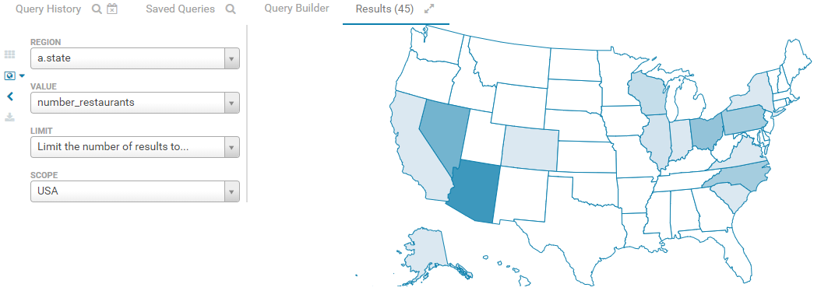

|  |
| --- |
| select  a.city  , count(distinct a.business_id) as number_city  from  business2 a  , restaurant b  where  a.business_id = b.business_id  group by a.city  order by number_city desc  ; |

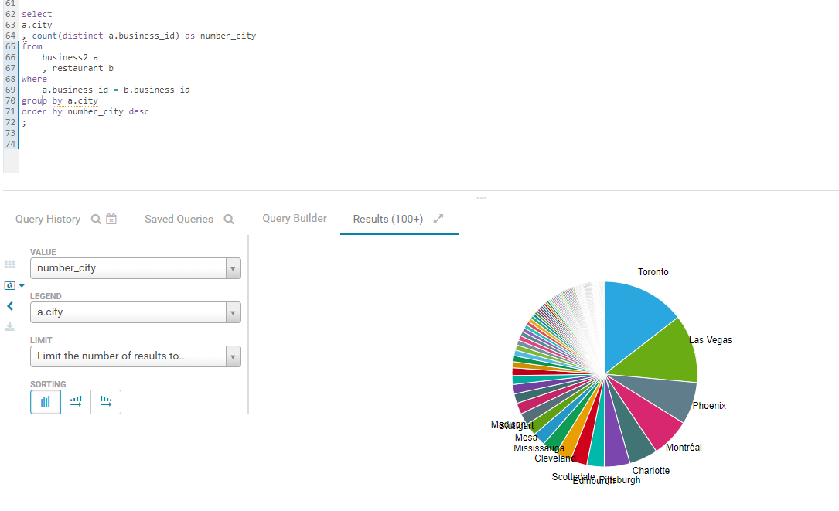

|  |
| --- |
| select  a.category  , count(distinct a.business_id) as number_cat  from  category a  , restaurant b  where  a.business_id = b.business_id  and a.category not in ('Restaurants','Food')  group by a.category  order by number_cat desc  limit 15; |

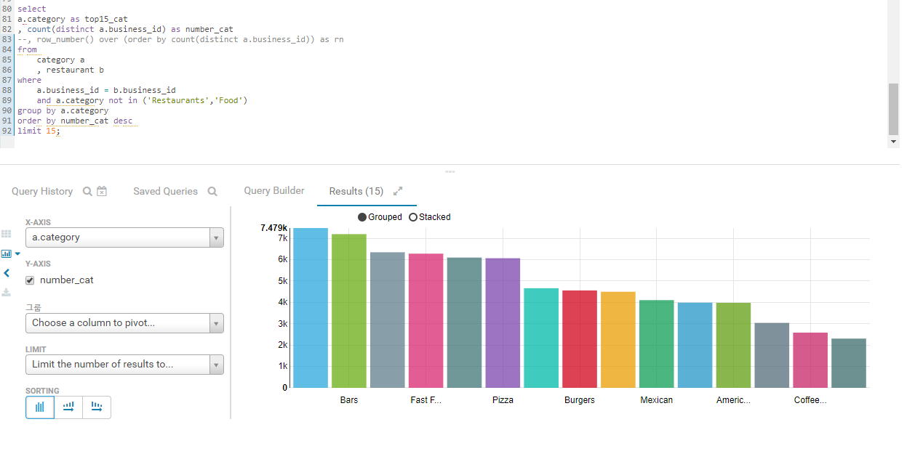

|  |
| --- |
| create table ratings  stored as parquet  as  select  b.category  , a.stars as ratings_star  , count(distinct a.business_id) as ratings_number  from  restaurant a  , category b  where  a.business_id = b.business_id  and b.category in ( "Nightlife","Bars", "Sandwiches", "Fast Food","American (Traditional)")  group by b.category  , a.stars  order by a.stars asc, ratings_number desc  ;  select * from ratings where ratings_star between 3 and 4  ; |

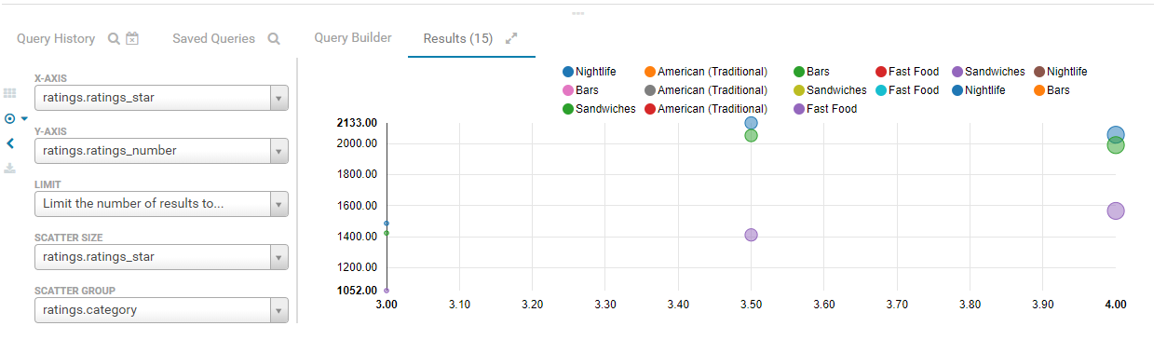

|  |
| --- |
| select  a.stars as ratings_star  , count(distinct a.business_id) as ratings_number  from  restaurant a  , category b  where  a.business_id = b.business_id  group by a.stars  ; |

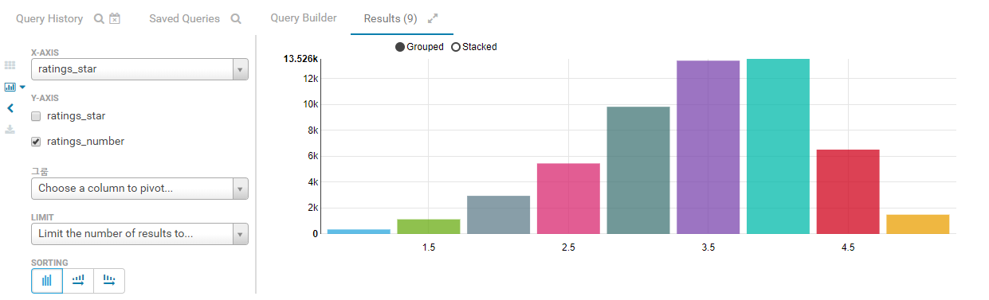

|  |
| --- |
| select  b.category  , count(distinct a.business_id) number_id  from  restaurant a  , category b  where  a.business_id = b.business_id  and a.stars >= 4  and b.category not in ('Restaurants','Food')  group by b.category  order by number_id desc  limit 10 |

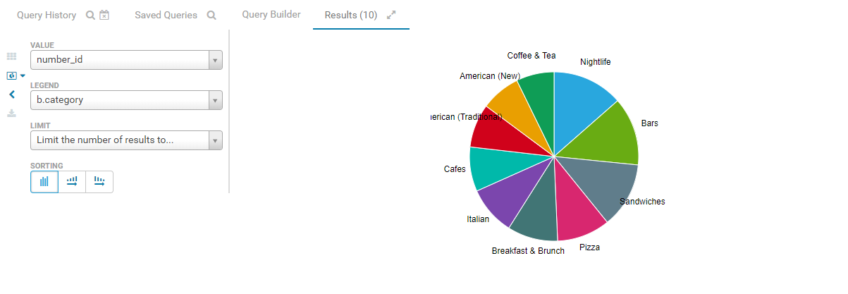

|  |
| --- |
| select  b.category  , count(distinct a.business_id) number_id  from  restaurant a  , category b  where  a.business_id = b.business_id  and a.stars <= 2  and b.category not in ('Restaurants','Food')  group by b.category  order by number_id desc  limit 10  ; |

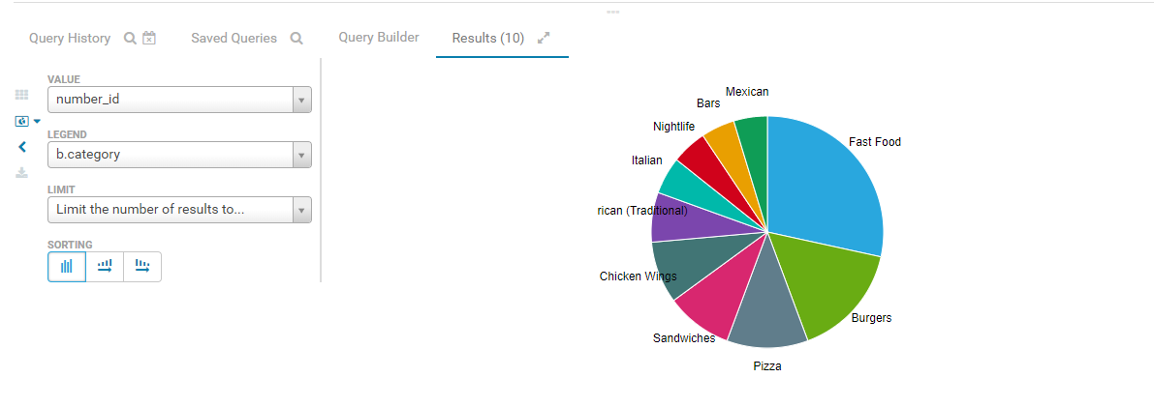

|  |
| --- |
| create table high_review  stored as parquet  as select  re.name name  ,b.city city  ,re.review_count review_count  ,re.stars stars  ,re.attributes["restaurantspricerange2"] restaurantspricerange2  from  restaurant re  , business b  where  re.business_id = b.business_id  order by review_count desc;  select * from high_review limit 15; |

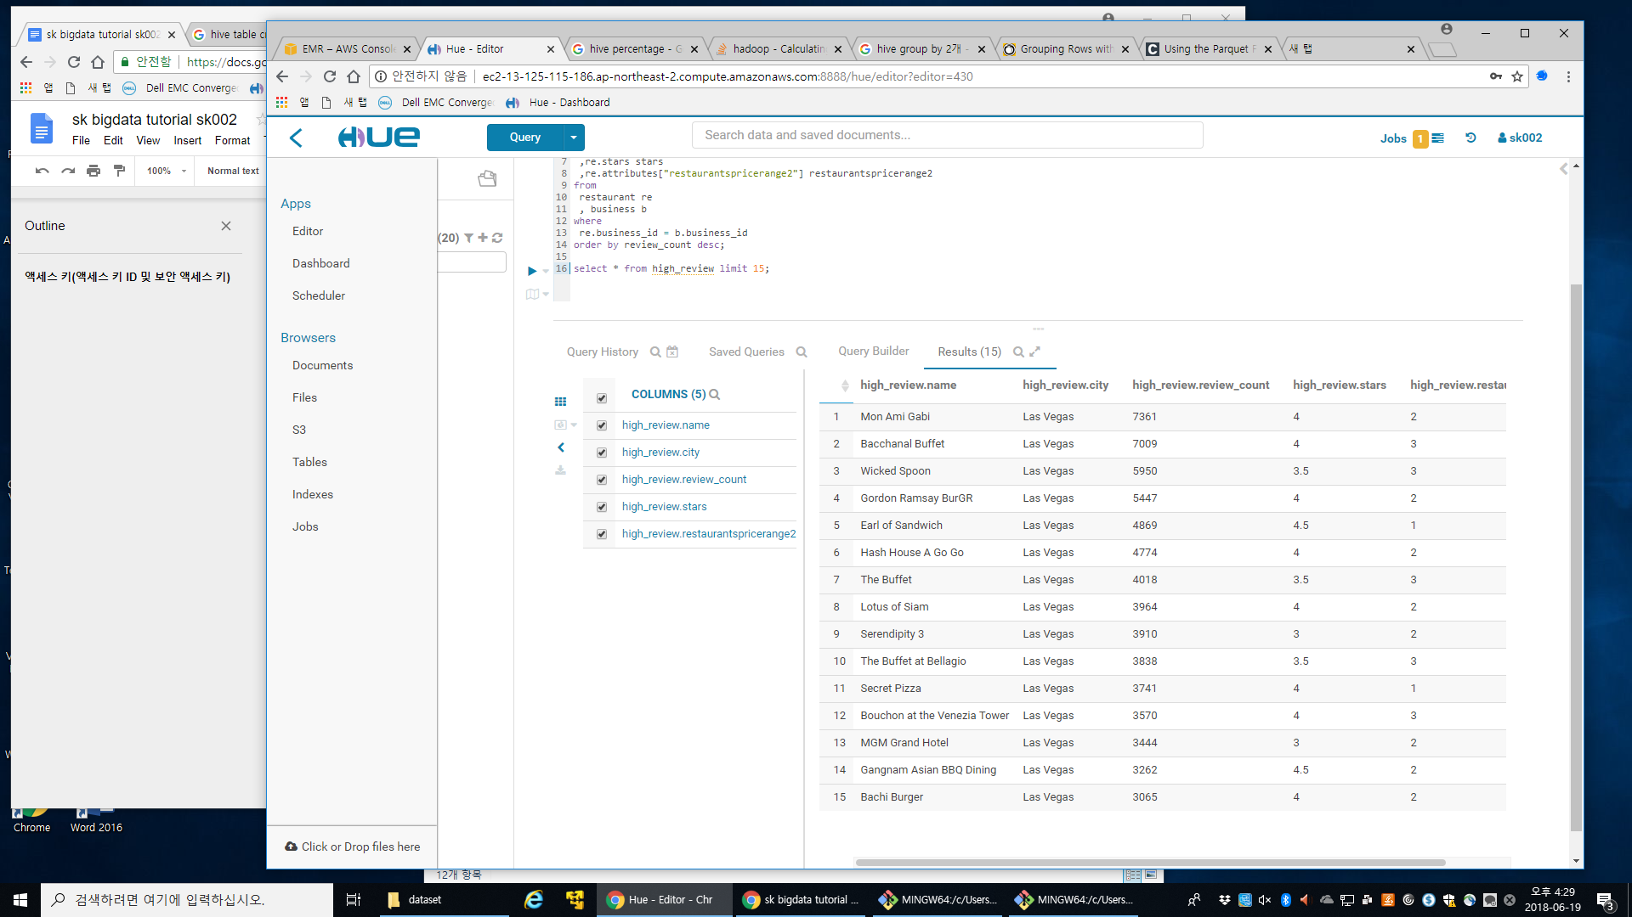

|  |
| --- |
| select elite_year, count(distinct user_id) as elite_user from elite_user  group by elite_year  order by elite_year  ; |

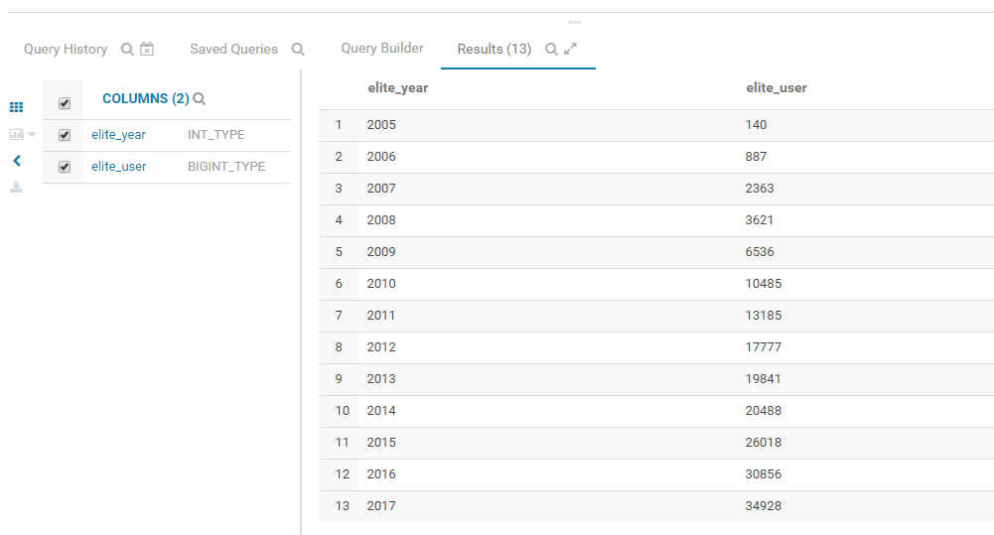

|  |
| --- |
| select elite_year, round(avg(average_stars),2) as avg_rating from elite_user  group by elite_year  order by elite_year  ; |

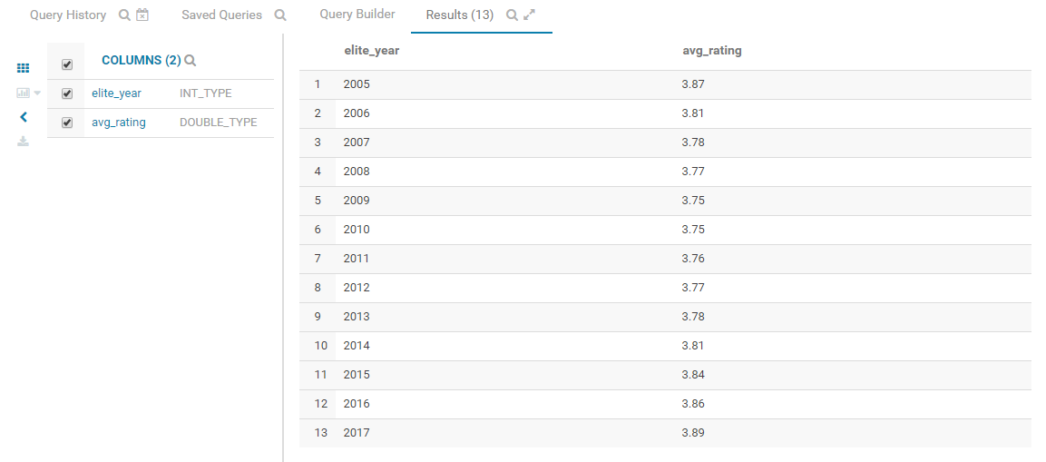

3일차

최종 발표 파일 작성